Object-Oriented Design

Sample Solution

Software Architecture Workshop (Java Properties File)



©2010 NUS. The contents contained in this document may not be reproduced in any form or by any means, without the written permission of ISS, NUS, other than for the purpose for which it has been supplied.

Sample Solution to Software Architecture Workshop

Transition Strategy for Java Properties File
The data storage and configuration files of the MaxVision case study will be implemented using the Java Properties file. While it is possible to leave some of the details in this strategy to the programmer, it is assumed in this exercise that we wish to model the design till the level of the key/value pairs of the Java Properties file.

Impacted Analysis Objects
All the entity objects that represent information that should be persisted are impacted. They are to be adapted to use the Java Properties objects to access the Java Properties files.

All the boundary, control and entity objects that interact with these entity objects are impacted. They are to be adapted to make requests to the adapted entity objects.

Impacted Use Cases
All the use cases that access (i.e. read or write) persisted data are impacted. For examples, Create Member and View Member Details use cases.

Transition of Static Structure
The following class diagram illustrates the static structure of the design.
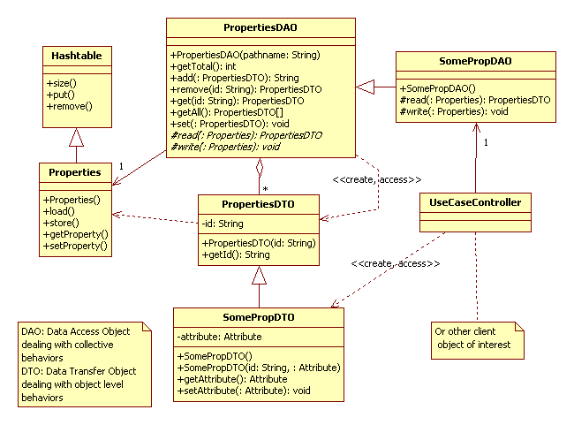

A persistent entity object would be mapped to a SomePropDAO object that manages the data access of a collection of SomePropDTO data objects. UseCaseController or other client object of interest can then access the SomePropDTO objects through the corresponding SomePropDAO object. In the MaxVision case study, Branch and Member are examples of persistent entity objects.

The PropertiesDAO class contains the generalized features of all DAO objects. It manages a collection of PropertiesDTO objects. It provides the common collective behaviours like the addition and removal of a PropertiesDTO objects. In particular, the SomePropDTO object must implement the reading of attributes of its SomePropDTO objects from a Properties object and the writing of these attributes to a Properties object. The object level behaviours are however provided by the SomePropDTO object itself

Taking the Member persistent entity object for example, it should be mapped to a MemberDAO object that inherits from PropertiesDAO that holds a collection of MemberDTO objects that inherits from PropertiesDTO.

The following sets of behaviours are supported for each persistent entity object:
- Collective behaviours
  - Loading of DTO objects from the properties file
  - Storing of DTO objects to the properties file
  - Getting the number of existing DTO objects
  - Getting all the existing DTO objects
- Object behaviours
  - Adding a new DTO object
  - Removing an existing DTO object
  - Retrieving the details of a DTO object
  - Modifying the details of a DTO object

Transition of Dynamic Interactions
The following sets of dynamic interactions are supported for each persistent entity object:
- Instantiation of a DAO
- Traversal of all the DTOs (including retrieval of the values of the attributes of the DTOs)
- Modification of values of the attributes of a DTO
- Addition and removal of a DTO (details are not provided here; for your practice)

The following sequence diagram illustrates the typical dynamic interactions of the design for the instantiation of a DAO usually done during the starting up of a system. For simplicity, we have chosen to load all the DTOs upon the instantiation of a DAO.

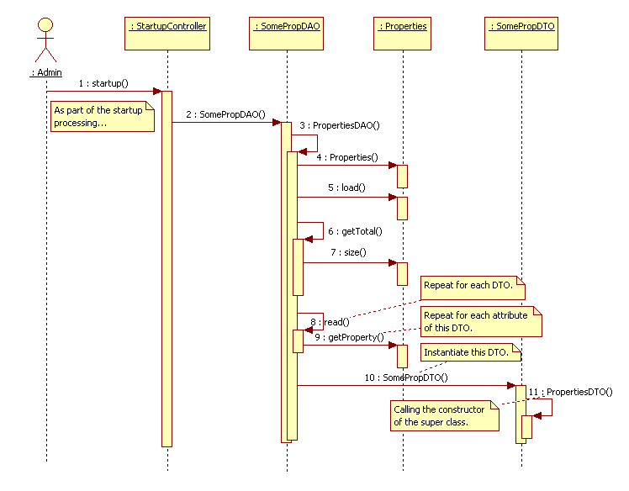
The following sequence diagram illustrates the typical dynamic interactions of the design for the traversal of all the DTOs and the retrieval of the values of the attributes of each DTO.

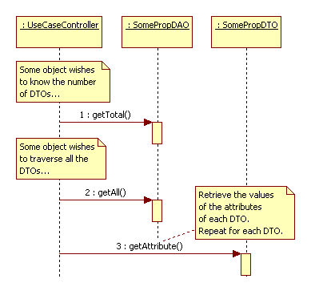

The following sequence diagram illustrates the typical dynamic interactions of the design for the modification of values of the attributes of a DTO.

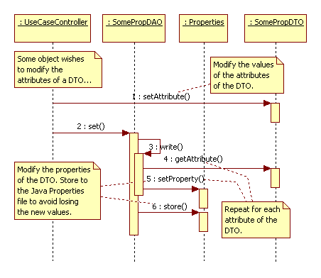
Note that we have chosen to save to the Java Properties file whenever a modified DTO object is set to the DAO. This step is crucial in avoiding the potential loss of data due to system crashes.

